**Riverside City College**

**Program Level Assessment Checklist**

This is a checklist / guide which can be used as a companion to your Program Level Assessment. For further information, please contact RCC’s Assessment Committee Faculty Co-chairs, Denise Kruizenga-Muro and Jude Whitton, or the Administrative Co-chair, Wendy McEwen.

**Completed SLO and program mapping**

**Ordered SLO to PLO report from Wendy McEwen**

**Reviewed course patterns and equity data**

**Identified key courses and assignments and collected samples of student work from those courses**

**Discussed with discipline/department how to assess the PLO and developed the assessment instrument**

**Assessed artifacts**

**Entered assessment results into Nuventive**

**Discussed results of assessment in discipline/department meeting and recorded the conversations in meeting**

**minutes.**

**(see explanations below)**

**STEP 1:** Review the map of the program’s courses AND SLO’s to the PLO’s.

The screenshot below is from the ADT for Communication Studies. It shows the mapping of SLOs to PLOs.

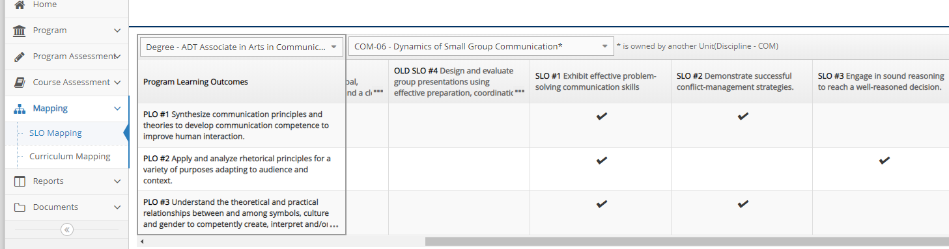

The screenshot below is from the Theatre ADT for Curriculum Mapping. If the course Introduces the PLO concept (“1”), Develops the concept (“2”), or Masters the concept (“3”).

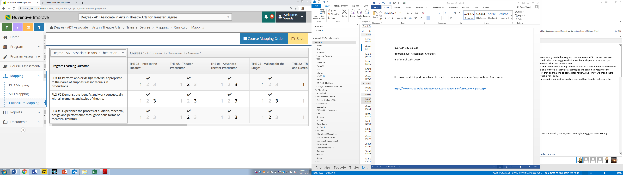

Questions to ask during mapping process:

1. Are the correct courses included in Nuventive? (If no, contact Wendy McEwen to add / revise / delete courses).
2. Are all of the included courses offered on an appropriate rotation schedule? If not, why not? Can students still successfully complete the program in a reasonable timeline?
3. Are all courses only introducing the PLO concepts? Is that ok?

**STEP 2:** Ask Wendy McEwen to create a report providing all SLO assessment results as it relates to PLO’s. Below is an example from CIS. This report provides you with an “at a glance” summary of all of the assessment activity as it relates to the PLO’s.



Questions to ask during SLO assessment review process:

1. Do any of the PLO’s have enough evidence from SLO assessment to successfully evaluate student work for that PLO? If yes, you can use the SLO evidence as part of the PLO assessment.
2. Do any PLO’s have no linked SLO Assessment? If yes, you might review the mapping and ensure that in the next SLO assessment cycle, courses that have SLO’s related to that PLO are assessed (you’ve identified a potential assessment gap)
3. Is there a course (s) which can be considered a key course or a capstone course which can be identified for continued PLO assessment?

**STEP 3:** Using documents from the Document Repository, review course patterns (using the Course Sections file) and disaggregated student success (using the Equity Success SX file).

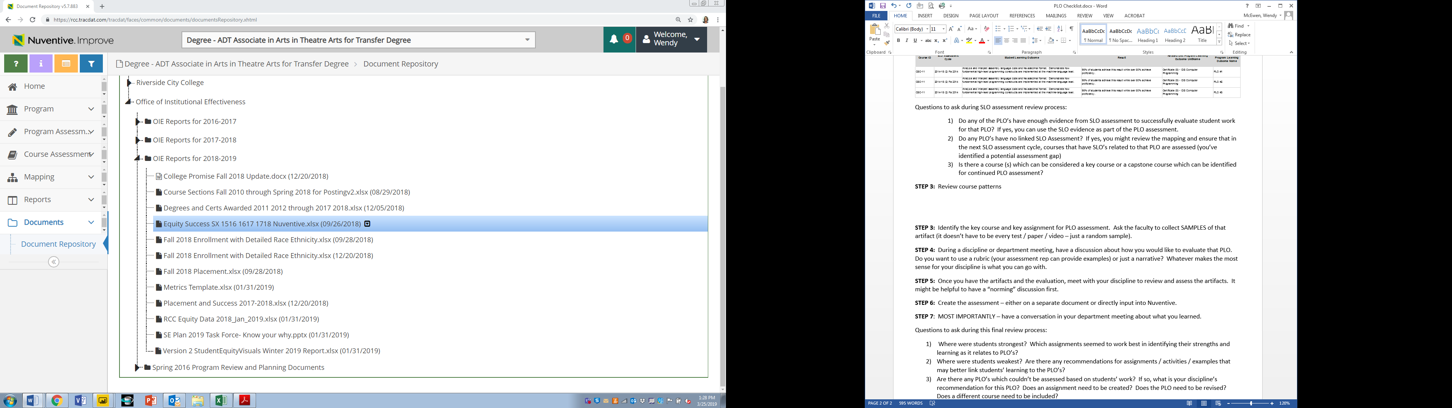

Questions to ask during this review process:

1. Are your course offerings balanced? Are you meeting your enrollment targets?
2. How is enrollment in your General Education courses? Which of your Gen Ed courses are being included in other departments’ program maps? Think about having a conversation with the department chair in that department to understand how your Gen Ed course is fitting into their needs.
3. Do you see any differences for success between student race / ethnicities? Between online and face-to-face offerings? Between other course characteristics? Why might that be? Particularly for student equity, if there is a success gap of 10% or more between race / ethnicity groups, have a department-wide discussion about how you might close this gap. What examples are you using in class? How engaged are the students? Who has tried a different delivery method, assignment, etc. that has resulted in increased student learning.
4. If you would like ideas or recommendations, contact Laura Greathouse for support.

**STEP 4:** Identify the key course and key assignment for PLO assessment. Ask the faculty to collect SAMPLES of that artifact (it doesn’t have to be every test / paper / video – just a random sample).

**STEP 5:** During a discipline or department meeting, have a discussion about how you would like to evaluate that PLO. Do you want to use a rubric (your assessment rep can provide examples) or just a narrative? Whatever makes the most sense for your discipline is what you can go with.

**STEP 6:** Once you have the artifacts and the evaluation, meet with your discipline to review and assess the artifacts. It might be helpful to have a “norming” discussion first.

**STEP 7:** Create the assessment – either on a separate document or directly input into Nuventive. See screenshot below:

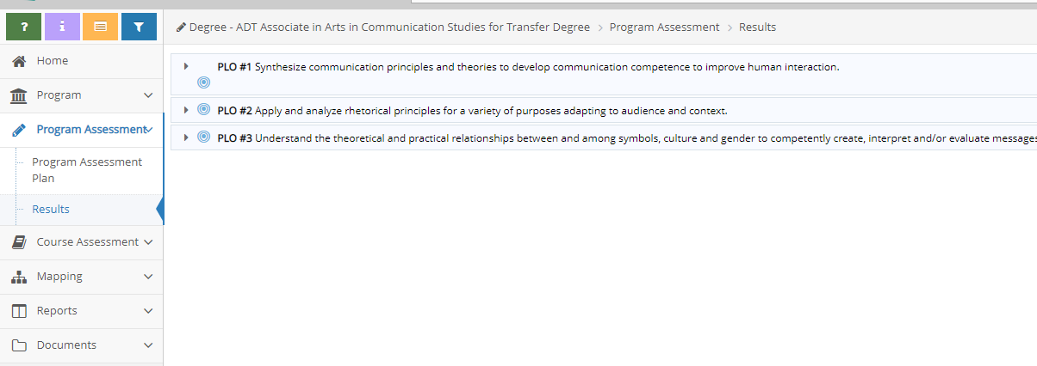

**STEP 8**: MOST IMPORTANTLY – have a conversation in your department meeting about what you learned.

Questions to ask during this final review process:

1. Where were students strongest? Which assignments seemed to work best in identifying their strengths and learning as it relates to PLO’s?
2. Where were students weakest? Are there any recommendations for assignments / activities / examples that may better link students’ learning to the PLO’s?
3. Are there any PLO’s which couldn’t be assessed based on students’ work? If so, what is your discipline’s recommendation for this PLO? Does an assignment need to be created? Does the PLO need to be revised? Does a different course need to be included?

Final notes – as with all assessment, contact your department assessment representative of any of the co-chairs for recommendations, examples, or support.